

BrewSense: AI-Driven Coffee Companion for Personalized Recommendations
By

Section No.

Student Name: Rawan Ali AL Shehri | University ID : 443809696
Student Name: Lama Mohammed AL Shehri | University ID : 443807183
Student Name: Shaden Abdullah AL Shahrani | University ID : 442809056

Supervised by
Dr. Asma Aldrees
Submitted to King Khalid University in fulfilment of the requirements for the B.Sc. Degree in Information Systems
Academic Year 2024-25/1445-1446 (Semester II)
Department of Informatics and Computer Systems
College of Computer Science
King Khalid University

Comments by Supervisor(s) / Examiner(s) Name signature of Supervisor and examiners
Name | Comments | Signature

Abstract
This project offers an application that serves coffee “A personalized coffee experience for coffee lovers.”
Lovers at a time when choices have multiplied, and decision-making has become time-consuming and effort-consuming. The application provides them with a unique and “Distinctive, by providing a recommendation system to offer a personalized experience, enhances the feeling through suggesting cafés using collaborative filtering.”
To make their routine experience smoother using machine learning techniques and Collaborative Filtering
Experience is supported by intelligence based on their personal preferences. In addition to providing suggestions for nearby roasters by integrating the GPS system and a strong database of roasters.
In Saudi culture, coffee is an essential part of our culture and traditions. The year 2022 has been declared the Year of Saudi Coffee, and coffee is called "green gold" for its economic and social value. Coffee is an essential element in any home or occasion, whether happy or sad. For generations, people have consumed and prepared coffee, and it is an integral part of our lifestyle. Through this project, to make it easier and better for everyone. By continuously learning from user feedback, the application improves recommendations while ensuring progress and innovation.

Declarations

We declare that this project is our work and effort, other than the texts taken, their sources have been referred to according to academic standards.

Acknowledgements

We thank allah (SWT) then we thank our families for their continuous support, and our supervisor Dr. Asma Aldrees for her guidance and advice.
Table of Contents
Comments by Supervisor(s) / Examiner(s) Name signature of Supervisor and examiners 2
Abstract 3
Declarations 4
Acknowledgements 5
Table of Figures 9
List of Tables 10
Chapter 1: Introduction and Background 11
1.1 Goal 11
1.2 Motivation 12
1.3 Signification 13
1.4 Method 13
1.5 Report Outline 14
1.5 Summary 14
Chapter 2: LITERATURE REVIEW 15
2.1 Introduction 15
2.2 Background 15
2.3 Adopted Techniques in Recommendation Systems 17
2.3.1 Deep Learning 17
2.3.2 Recommendation System 18
2.4 Related Works 19
2.4.1 Beanhunter Application 20
2.4.2 European Coffee Trip 21
2.4.3 Cups: Coffee Subscription Application 22
2.4.4 CoffeeGuru Website 23
2.5 Problem Statement 24
2.6 Comparison of Related Works 25
2.7 Research Questions 25
2.6 Summary 25
Chapter 3: PROJECT MANAGEMENT 26
3.1 Introduction 26
3.2 Approach 26
3.3 Risk Management 27
3.4 Project Plan 28
3.5 Summary 28
Chapter 4: Requirements and Analysis 29
4.1 Introduction 29
4.2 Feasibility Analysis 29
4.2.1 Technical Feasibility 29
4.2.2 Operational Feasibility 30
4.2.3 Economic Feasibility 30
4.2.4 Schedule Feasibility 31
4.3 Requirement Elicitation 31
4.3.1 UML Diagrams 31
4.4 System Requirements 31
4.4.1 Hardware Specifications 31
4.4.2 Software Specifications 32
4.5 System Requirements 33
4.5.1 Functional Requirements 33
4.5.2 Non-Functional Requirements 34
4.6 Personas 34
4.7 System Models 35
4.7.1 Use Case Diagram 35
4.7.2 Sequence Diagram 36
4.8 Summary 39
Chapter 5: System Design 42
5.1 Introduction 42
5.2 Mobile Interfaces 42
5.2.1 Splash Interface 42
5.2.2 Sign-up Interface 43
5.2.3 Login Interface 43
5.2.4 Reset Password Interface 44
5.2.5 Cafes Recommendation Interface 44
5.2.6 Admin Manage Users Interface 45
5.3 Data Storage 46
5.3.1 Entity-Relationship (ER) Diagrams 46
5.3.2 Data Dictionary 47
5.4 High-Level Design 48
5.4.1 Class Diagram 48
5.4.2 System Architecture 50
5.5 Summary 50
Chapter 6: Conclusion and Future Work 51
6.1 Future Work 51
6.2 Summary 52
REFERENCES 53

Table of Figures
Figure 2. 1: Beanhunter Application 20
Figure 2. 2: European Coffee Trip 21
Figure 2. 3: Cups: Coffee Subscription App 22
Figure 2. 4: CoffeeGuru Website 23
Figure 3. 1: Agile Methodology 26
Figure 3. 2: Project Plan 28
Figure 4. 1: Use Case Diagram 36
Figure 4. 2: Sequence Diagram for Sign-Up 37
Figure 4. 3: Sequence Diagram for Login 38
Figure 4. 4: Sequence Diagram for Cafes Recommendations 39
Figure 5. 1: Home Interface 42
Figure 5. 2: Sign-up Interface 43
Figure 5. 3: Login Interface 43
Figure 5. 4: Reset Password Interface 44
Figure 5. 5: Cafes Recommendation Interface 44
Figure 5. 6: Admin Manage Users Interface 45
Figure 5. 7: Entity-Relationship (ER) Diagrams 46
Figure 5. 8: Class Diagram 49
Figure 5. 9: System Architecture 50

List of Tables
Table 2. 1: Comparison Table of Related Works 25
Table 3. 1: Software Requirements 32
Table 5. 1: Table 1: User 47
Table 5. 2: Preferences Table 47
Table 5. 3: AI Model Table 48
Table 5. 4: The Admin Table 48

Chapter 1: Introduction and Background

In this chapter, we provide an overview of our project. Coffee is one of the most consumed drinks in the world and one of the successful businesses at present. Despite the many options and diversity, we face problems in choosing what matches our needs and personal preferences. Therefore, we combine everyone's favourite drink with the nerve of the digital future at present. We will present the objectives of our project, our motivations for this project, the importance of the project, and the methods used in the project, in addition to a brief overview of the main issues that will be discussed in the following chapters of the report.

1.1 Goal
- The primary goal is to develop a smart personalized recommendation system that enables users to select coffee based on their personal preferences. The app aims to develop an AI-powered application that utilizes machine learning algorithms such as collaborative filtering, that is designed according to each user's preferences, ensuring a personalized and more efficient experience that saves time and decision-making.
- The application not only provides coffee selection recommendations but also integrates with GPS technology and a database containing nearby cafes or roasteries. This allows the app to filter data and offer suitable recommendations to the user. Also supporting local trade, through recommended roasters for the user.
- Seeking to make offers capacity scaling as needed, allowing for flexible data storage. This capability enables future growth without impacting performance. Also, contributes to designing user-friendly interfaces with intuitive options and easy-to-navigate, minimizing ‏clicks as much as possible. Additionally, the app aims for full compatibility with various screen sizes and dimensions. It includes features such as a dark mode option and user-customizable notifications to continuously provide a user-friendly experience.
- aspires to continuous learning, which involves monitoring user interactions and analyzing behavioural patterns. It extracts precise data about their evolving preferences in a continuous, in-depth, and comprehensive manner, thereby enabling it to accurately infer suitable recommendations that adapt to changes in the user's tastes.

1.2 Motivation
Because coffee is one of the most consumed drinks in the world and the demand for it has recently increased significantly, for this reason there is a great diversity in coffee types, roasting degrees and preparation methods, for this reason the need for smart recommendation systems (AI-powered) has increased to suit different tastes, so our main and first motivation for creating this project is the lack of coffee applications that use ai AI-powered and are based on personalized recommendation system (PRS), in addition to providing the experience of nearby cafes that suit their taste and enhance the coffee experience and make it more enjoyable.
Providing a personal experience: Due to the availability of various and many options, using AI-powered customizes a system based on the user's personal preferences, such as roasting levels, preferred acidity, or preferred brewing methods.
Facilitating decision-making: Most people rely on friends' recommendations or their random experience, and often other options are satisfactory to them, so we want our application to make the task easier for them, save effort and time, and guarantee them an experience that suits their taste and is satisfactory to them.
Providing a user-friendly application: It is an easy-to-use application for everyone and benefits all coffee lovers, whether they are beginners or experts.
High consumption of coffee: Coffee is one of the most consumed. For this reason, we seek to make our application suitable for the largest segment of people, as the Kingdom of Saudi Arabia is one of the ten countries that consume coffee, with 80 thousand tons annually.
Integrating coffee with AI-powered: Integrating the routine and traditional experience of coffee with the latest AI-powered technologies and making it more accurate, easy, and enjoyable

1.3 Signification
Helping coffee lovers make decisions: Using an AI-powered based on personalized recommendation system (PRS) will contribute to making appropriate decisions and allow users to discover the coffee that suits their taste instead of unsatisfactory experiences for them
Saving time and effort: In addition to being an application that seeks to provide recommendations and reduce wasted search time, it is also supported by technologies to facilitate use, which is an additional reason to save time and effort in searching and experimenting
User confidence in satisfactory recommendations: When successful in providing satisfactory suggestions, users will gain confidence in the application, which makes them rely on it in every experience to obtain suggestions that suit their taste.
Providing a nearby cafes experience: Allows users to add their location to suggest the best cafes and roasters based on their personal preferences.
Easy-to-use application: Using AI-powered and a clear and easy user interface, this facilitates the process of use effectively and easily, and ensures an enjoyable experience for them, and is smooth with different systems, which allows users to easily access.

1.4 Method
Software development lifecycle (SDLC) in an Agile environment
- Planning: Define the project scope and goals, creating a flexible plan based on feedback.
- Requirements Gathering & Analysis: To collect data from the user, understand and analyze it to make smart recommendations, choose AI-powered technologies.
- Design Phase: After collecting all requirements, Team meetings are held to complete the divided design tasks, such as architecture, system design, database design, and UI/UX.
- Development and Implementation: Based on the outputs and selected technologies, members will begin building and coding.
- Testing and verification: Each stage is tested frequently to ensure the correctness of the workflow, with correction and performance improvement if necessary.
- Maintenance: After testing and validation, the next step is iterative to continuous maintenance in which feedback is collected and discussed, everything that has been implemented and tested is reviewed to ensure quality.

1.5 Report Outline
After completing the first chapter, which covered the project's objectives and significance, the report now proceeds to a review of key points that will be explored in the upcoming chapters.
- Chapter 2: a review of current research related to smart recommendation system that enables users to select coffee
- Chapter 3: Overview of Project Management with more details about the methodologies used, as well as the potential risks.
- Chapter 4: Detailed System Requirements Analysis| including functional and non-functional.
- Chapter 5: System Design Discussion including product features, User interface.
- Chapter 6: Conclusion of the Detailed Implementation Description with future works in this project.

1.5 Summary
In this chapter, we provided an overview of our project. Coffee was one of the most consumed drinks in the world and one of the successful businesses at the time. Despite the many options and diversity, we faced problems in choosing what matched our needs and personal preferences. Therefore, we combined everyone's favourite drink with the nerve of the digital future at the time. We presented the objectives of our project, our motivations for this project, the importance of the project, and the methods used in the project, in addition to a brief overview of the main issues that were discussed in the following chapters of the report.

Chapter 2: LITERATURE REVIEW

2.1 Introduction
In the preceding chapter, we delved into the problem statement, project impact, and the scope of our project. We thoroughly examined the aims and objectives guiding our project. In this chapter, we shift our focus to conducting a comprehensive literature review. This review is aimed at comparing, analyzing, exploring, and gaining a deeper understanding of prior research efforts in this field. It serves the purpose of identifying existing knowledge and pinpointing research gaps that our project can address.

2.2 Background
In a world that has witnessed a great development in technologies supported by AI, especially in data analysis and decision-making, it ‏also witnessed several technologies that have contributed to improving the coffee experience.
The study “Recommendation System using Machine Learning Techniques” highlighted the use of algorithms such as KNN (K-Nearest Neighbors), SVD (Singular Value Decomposition), and ALS (Alternating Least Squares) to improve the accuracy of recommendations, and how to use content-based filtering and collaborative filtering to analyze user data. The study mentioned challenges facing recommendation systems such as dealing with constantly changing user preferences, but they can be dealt with using temporal data analysis techniques to update recommendations based on changes in the input data patterns. The study also discussed the lack of diversity in recommendations and the difficulty of expanding with the increasing volume of data faced by traditional recommendation systems.[1]
The second study, “Personalized Recommendation Systems (PRES): A Comprehensive Study,” also goes into more detail about how recommendation systems are personalized based on a user’s data, showing that both content-based filtering and collaborative filtering are linked in a common recommendation system to ensure high accuracy in suggestions. The study pointed out the “Cold Start Problem”, which occurs when there is not enough data available about the new user. The study also added the importance of collecting Deep Learning in recommendation systems to analyze the patterns of the entered data and predict user preferences. Among the applications cited by the study are recommendation systems in movies and music, as it explained that improving the accuracy of recommendations requires analyzing the user's interaction with the recommendations provided to them. [2]
In a study that evaluated the quality of coffee beans based on digital image analysis, Arabica beans from Guatemala were used with three different roasting levels (light, medium, and dark) using machine learning techniques and convolutional neural networks (CNNs). The study mentioned that colors were analyzed using the Lab* and RGB models, and the RGB model was more accurate in distinguishing between the different levels. The study also stated that a Nikon D5100 camera was used to capture high-resolution images, which were processed by removing the background, converting them to PNG format, and resizing them to 678 × 678 pixels to make processing easier. After that, a CNN network was developed, consisting of four convolutional layers (Conv2D), four pooling layers (MaxPooling), a dropout layer (Dropout) to prevent overfitting, and a prediction layer for the final coffee quality classification. This model was trained using the Adam algorithm with 55 epochs, and the model achieved 81% accuracy in classifying. The idea can be integrated into this project by collecting user ratings for coffee suggestions and improving the accuracy of recommendations based on their reactions. Research on this topic contributes to exploring new ideas for integrating technologies with experiences dedicated to providing a distinctive individual experience for coffee lovers [3].
This paper introduces a recommendation system tailored for coffee shops in Tangerang, Indonesia, helping users choose cafes based on their preferred criteria. The system applies Multi-Criteria Decision Making (MCDM) methods, specifically using the Analytical Hierarchy Process (AHP) to determine the importance of each criterion and the Technique for Order of Preference by Similarity to Ideal Solution (TOPSIS) to rank 50 coffee shop options. The dataset includes these 50 alternatives, with each evaluated based on criteria weights set by users. The system’s effectiveness was validated through the Usefulness, Satisfaction, and Ease of Use (USE) Questionnaire, where it achieved a high score of 87.6%, demonstrating its reliability and ease of use in guiding users to suitable coffee shop choices [4].

The proposed solution in this paper introduces a personalized attraction recommendation system (PTIS) that leverages Facebook check-in data to recommend tourist attractions, addressing the common "cold-start" problem by incorporating check-in data from users’ friends to enrich profiles and improve recommendation quality. The system uses a Friend-based Collaborative Filtering (FCF) approach, combining location data, social relationships, popularity metrics, and time awareness to generate more relevant suggestions. Evaluated using Facebook check-in data, the PTIS achieved an impressive average precision of 72.24%, outperforming traditional content-based and collaborative filtering approaches, which scored 57.03% and 68.76%, respectively, proving its effectiveness in enhancing recommendation accuracy by learning dynamically from social connections [5].
This paper proposes a localized product recommendation system tailored for automatic vending machines, aiming to provide personalized product suggestions based on customer preferences in different locations. The system applies a hybrid approach, combining K-means clustering to group products, Decision Tree classification to guide product selection, Bayesian Network to analyze relationships between product attributes and customer preferences, and Genetic Algorithm (GA) to optimize product selection for maximum attribute coverage. The system was tested using transaction data from nine vending machines in two districts of Taipei, Taiwan, collecting over 50,000 records during a two-month period. Results showed a significant sales boost, with sales increasing by two to four times after implementation, proving the system’s effectiveness in adapting to local customer preferences and enhancing vending machine performance [6].

2.3 Adopted Techniques in Recommendation Systems
A Recommendation System is a smart technology designed to help users discover products, services, or content that match their preferences without having to search manually. It works by analyzing user behavior, preferences, and historical interactions to predict what items (like coffee drinks or cafés) the user might like [10].

2.3.1 Deep Learning
Recurrent Neural Networks (RNN) play a vital role in enhancing AI-Driven Coffee Companion for Personalized Recommendations Application by enabling the application to understand and predict user preferences over time. Unlike traditional models that treat every order separately, RNN remembers the sequence of past orders, allowing the app to detect patterns, seasonal trends, and evolving tastes. This helps application offer smarter, context-aware recommendations — suggesting drinks and nearby cafés that match not only the user’s taste but also the time of day, weather, and current trends.
By learning continuously from each interaction, RNN ensures that the application delivers a highly personalized and dynamic coffee experience, making it easier for coffee lovers to discover their perfect cup effortlessly [7].

2.3.2 Recommendation System
There are several techniques used in recommendation systems, but the most common ones are:
1️. Collaborative Filtering
One of the powerful machine learning techniques that filter and evaluate is based on the opinions of others. (CF) contains large opinions, which helps filter data and provides accurate decisions [7]
Collaborative filtering methods learn a model based on the user's previous behavior and through similar decisions that other users have made [8].
- This technique recommends items based on what similar users liked.
- Example: If User A and User B both love caramel lattes, and User B also enjoys Spanish lattes, the system will recommend Spanish lattes to User A.
- Focus: User similarity (learning from others).
2️. Content-Based Filtering
It is a special type of filtering in that it filters large data that is of interest to users or useful and is considered a classification task. The model used for the filtering system divides the data into two parts: positive (relevant to the user), and negative (and irrelevant to the user). The training set is formed based on the elements that the user finds interesting. [8]
Filtering based on the Content of many detailed properties of any element, and this is to recommend other similar elements [9]
- This technique recommends items similar to what the user has already liked.
- Example: If a user loves caramel-flavored drinks, the system will recommend other caramel or sweet drinks.
- Focus: Item similarity (learning from the item features).

3️. Item-to-Item Recommendation
- This technique compares items directly to each other based on their attributes and popularity.
- Example: If a user orders cappuccino, the system might recommend a flat white because both share similar characteristics (milk-based espresso drinks).
- Focus: Finding related items.
In our application, we will use a hybrid model that combines Collaborative Filtering and Content-Based Filtering to provide accurate, diverse, and personal recommendations for both drinks and cafés. This ensures users get suggestions based on their own taste and what’s popular among similar coffee lovers in Abha. This blend of personal taste and community trends makes the recommendation system smarter and more helpful over time.
4. Supervised Learning for Recommendation Enhancement
We will also incorporate Supervised Learning techniques to refine our recommendations. By training models on labeled data—such as user preferences, reviews, and historical selections, the system can predict user satisfaction more effectively. Algorithms like Decision Trees, Random Forest, and Neural Networks will be used to analyze patterns in user behavior, improving recommendation precision [8].
By combining Collaborative Filtering, Content-Based Filtering, and Supervised Learning, our system will provide diverse, accurate, and evolving recommendations, ensuring that users always discover drinks and cafés that match both their tastes and popular choices among similar coffee enthusiasts.
5. User-Based Collaborative Filtering
This method suggests drinks and cafés based on the preferences of similar users. It works by identifying users with comparable tastes and recommending items that those similar users have liked but the current user has not tried yet. This ensures that coffee lovers in Abha receive recommendations influenced by trends within their community, making the experience more engaging and socially relevant [9].

2.4 Related Works
In this section, we will explore four existing systems that offer coffee-related recommendations and services. Each of these platforms provides unique features that contribute to enhancing the coffee experience for users. By analyzing their functionalities, we can identify strengths and limitations that will help us refine and optimize our own application.

- Beanhunter Application
- European Coffee Trip
- Cups: Coffee Subscription Application
- CoffeeGuru Website

2.4.1 Beanhunter Application
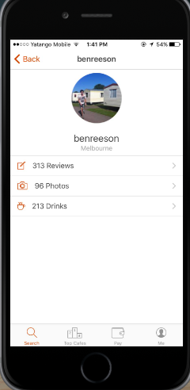
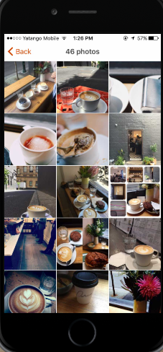
Beanhunter is a popular coffee discovery app that helps users find highly rated coffee shops in their area. It allows users to browse coffee shops, read reviews, and share their own experiences [11].
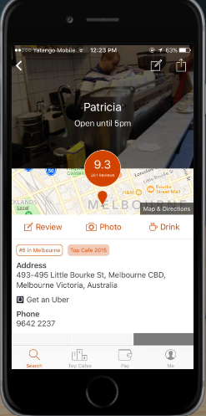
Figure 2. 1: Beanhunter Application
Pros:
- Provides user-generated reviews and ratings.
- Covers multiple global cities.
- Simple interface with search filters.
Cons:
- Focuses only on café discovery, not personalized coffee recommendations.
- Limited Database in Some Locations – Smaller towns or less popular areas have fewer coffee shop listings.
- User Interface Could Be Improved – Navigation feels cluttered or unintuitive for some users.
- Slow Updates on New Cafés – New coffee shops take time to appear in the app.
- Occasional Bugs & Performance Issues – Some users report crashes or slow load times

2.4.2 European Coffee Trip
European Coffee Trip hand-curates a list of specialty coffee shops across Europe, from major cities to small villages, to guide you to excellent coffee shops nearby , database application includes over 2,500 coffee shops in 39 countries [12].
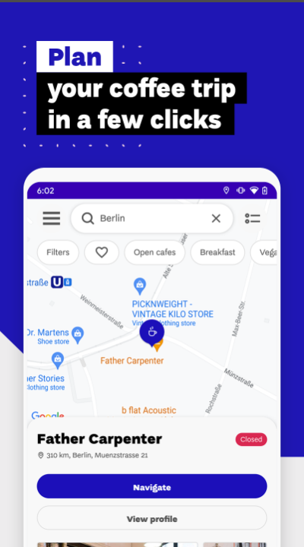
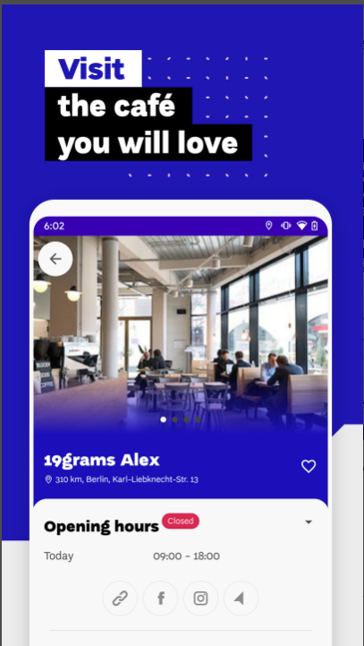
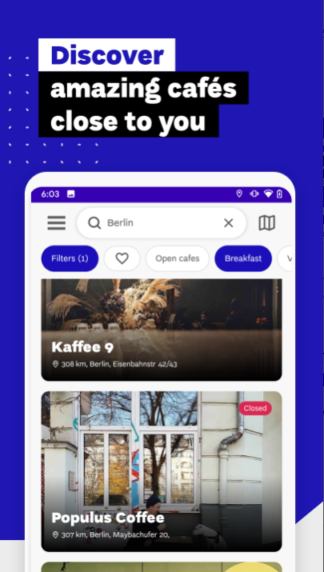
Figure 2. 2: European Coffee Trip

Pros:
- Covers multiple global cities.
- Simple interface with search filters.
Cons:
- Focuses only on café discovery, not personalized coffee recommendations.
- Declining Coverage and Updates: Users have observed that Beanhunter's coverage has diminished over time, with fewer updates and less active user engagement. ​
- Inclusion of Non-Specialty Cafes: The app sometimes lists establishments that aren't focused on specialty coffee, making it challenging for users seeking high-quality coffee experiences. ​

2.4.3 Cups: Coffee Subscription Application
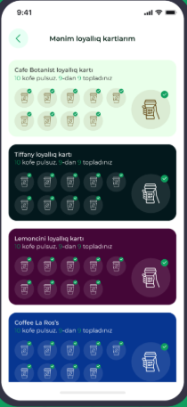
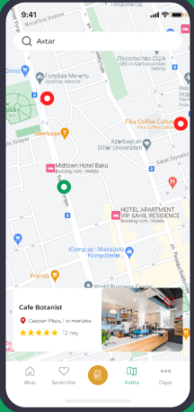
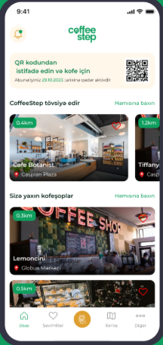
Cups is a subscription-based service that allows users to pre-pay for coffee at participating independent cafes. It focuses on saving money for frequent coffee buyers [13].

Figure 2. 3: Cups: Coffee Subscription App
Pros:
- Cost-saving for regular coffee lovers.
- Supports local independent cafes.
- Integrated map of partner cafes.
Cons:
- Focuses only on café discovery, not personalized coffee recommendations.
- The app has relatively low download numbers, with over 100 installs, and lacks user reviews on the Google Play Store, making it challenging to assess user satisfaction and app performance. ​
- Additionally, the app's functionality appears to be centred around Baku, Azerbaijan, which may limit its usefulness for users in other regions.​

2.4.4 CoffeeGuru Website
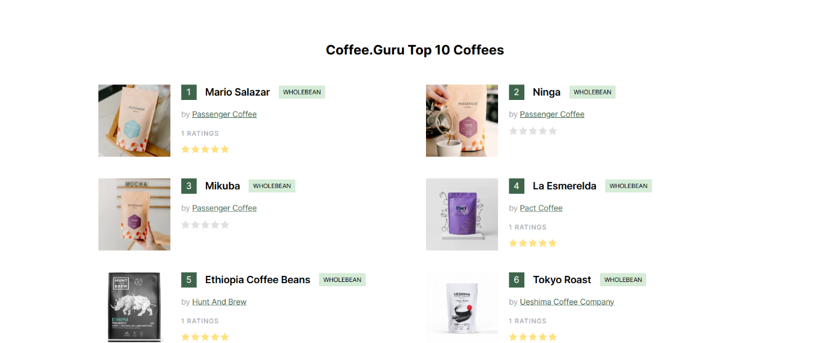
CoffeeGuru is a coffee shop directory that focuses on specialty focus on coffee beans, It offers basic location search, ratings, and user comments [14].

Figure 2. 4: CoffeeGuru Website
Pros:
- Focus on specialty coffee.
- Global database with good coverage.
- Includes basic reviews and ratings.
Cons:
- Focuses only on café discovery, not personalized coffee recommendations.
- Limited Brewing Methods: Some users have expressed a desire to include additional brewing techniques, such as the moka pot. ​
- There have been reports of the app being unavailable on certain platforms, particularly the Apple App Store in specific regions. ​

2.5 Problem Statement
In an era where coffee culture has flourished, coffee lovers face a paradox of choice countless cafes, roasters, and coffee styles are available, making decision-making increasingly time-consuming and overwhelming. While existing applications like Beanhunter, CoffeeGuru, and others help users find cafes, they primarily focus on location-based discovery or generic user reviews, without understanding the personal preferences of each individual user.
Core Problems with Existing Applications:
- Lack of personalized recommendations based on taste preferences.
- Most apps focus on café discovery only, not drink-level recommendations.
- Limited focus on local coffee culture — global apps do not cater to city-specific needs (e.g., coffee culture in Abha, Saudi Arabia).
- Decision fatigue – users spend excessive time reading through reviews, menus, and locations without personalized guidance.
- Specialty roasters, who might not operate large cafes, are often overlooked.
Our proposed solution is designed to be the ultimate intelligent companion for coffee lovers in Abha. By combining machine learning algorithms with personal taste profiling, our application learns what the user loves (e.g., roast preferences, milk preferences, flavors) and delivers customized drink and café recommendations. Additionally, it highlights nearby roasters — even those without physical cafes — ensuring users discover hidden gems in the local coffee scene. This makes every coffee outing smoother, faster, and perfectly tailored to the user’s preferences.

2.6 Comparison of Related Works
This section shows a comparison based on the similar functional requirements used in the applications. Table 2.1 illustrates the comparisons based on 6 features of similar apps.
Table 2. 1: Comparison Table of Related Works
Feature/Criteria | Beanhunter | European Coffee Trip | Cups | CoffeeGuru | Proposed Solution
Focus on coffee beans | Yes | No | Yes | Yes | Yes
Personalized Recommendations | No | No | No | No | Yes
Integration with Google maps API | Yes | Yes | Yes | No | Yes
Location Focus | Global | Global | Limited to partners | Global | Abha, Saudi Arabia
Platform | Android and iOS | Android and iOS | Android | Website | Android and iOS
Language | English | English | English | English | Arabic

2.7 Research Questions
The project questions are:
- How can apply recommendations techniques be applied to analyze individual coffee preferences and provide personalized drink recommendations?
- How effectively can machine learning models personalize coffee shop recommendations based on user preferences?
- What challenges arise when applying recommendation techniques to handle uncertain user preferences or inconsistencies in coffee recommendation systems?

2.6 Summary
In the preceding chapter, we delved into the problem statement, project impact, and the scope of our project. We thoroughly examined the aims and objectives that guided our project. In this chapter, we shifted our focus to conducting a comprehensive literature review. This review was aimed at comparing, analyzing, exploring, and gaining a deeper understanding of prior research efforts in this field. It served the purpose of identifying existing knowledge and pinpointing research gaps that our project addressed.

Chapter 3: PROJECT MANAGEMENT

3.1 Introduction
This chapter thoroughly examines the project's execution strategy, outlining the methods and frameworks used to manage its complexities. It provides a clear summary of the project's risks and the proactive steps taken to reduce challenges and maintain a smooth workflow. Additionally, the chapter highlights the project timeline, focusing on key milestones, deadlines, and phases. By analysing our approach, risk management strategies, and organized timeline, this chapter offers readers a comprehensive understanding of the rationale behind the project's execution.

3.2 Approach
As shown in Figure 3.1, the software development process typically follows several major stages to ensure the successful creation and ongoing maintenance of the application. These stages are as follows:
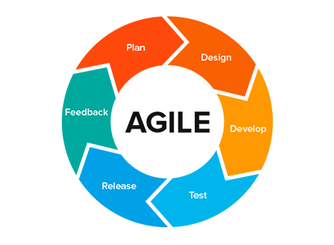

Figure 3. 1: Agile Methodology
- Requirements: This phase involves gathering and identifying the expectations and needs of stakeholders for the software product. It includes eliciting requirements, analyzing their feasibility, and documenting them.
- Design: In this phase, a blueprint for the software architecture and its components is created. This includes user interface design, system architecture, database schema.
- Implementation: During this phase, the software is programmed and built based on the design specifications. Developers write code, integrate different modules, and ensure that the software works as intended.
- Verification: In this phase, the software is thoroughly tested to identify and fix any errors or defects. Different testing techniques are used, such as unit testing, integration testing, and system testing.
- Maintenance: This final phase involves providing ongoing support and updates to the software after it has been deployed. This may include fixing bugs, improving features, and adapting the software to new requirements

3.3 Risk Management
The following risk management plan outlines key risks and strategies to mitigate them:
- Technological Risks and Migration Plan
- Risk: The rapid pace of technological advancements could render parts of the system obsolete within a few years.
- Migration: Use widely adopted frameworks and technologies with strong community support.
- Project Management Risks and Migration Plan
- Risk: Development delays due to technical issues or resource constraints may impact project timelines.
- Migration: Implement agile project management methodologies for better adaptability and allocate buffer time in the project timeline to accommodate unforeseen delays.
- Maintenance Risks and Migration Plan
- Risk: Post-launch maintenance, including bug fixes, updates, and feature enhancements, can be resource intensive.
- Migration: Develop clear documentation and coding standards to simplify future updates.

- AI Algorithm Accuracy
- Risk: Wrong recommendations may annoy users.
- Cause: Not enough data, user preferences misunderstood, data bias.
- Migration: Keep training the AI, collect user feedback, combine multiple recommendation techniques (Hybrid Filtering).
- GPS Accuracy
- Risk: Wrong café locations, poor user experience.
- Cause: Weak GPS signal, phone GPS errors, outdated café locations.
- Migration: Use GPS + WiFi + Cell Tower data, allow manual location edits, verify café locations regularly.

3.4 Project Plan
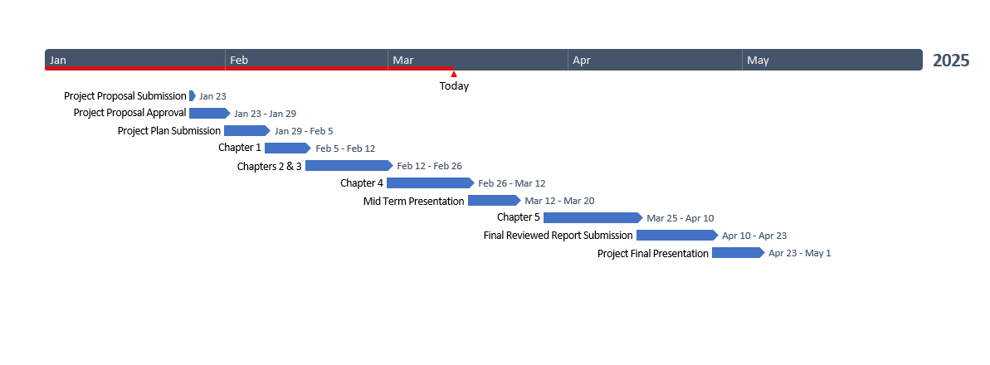
To develop this project, a schedule was established utilizing an online Gantt chart tool called Office Timeline. As depicted in this Figure, the timeline was created to outline the key dates and milestones for the project's execution, as shown in Figure 3.2.
Figure 3. 2: Project Plan

3.5 Summary
This chapter thoroughly examined the project's execution strategy, outlining the methods and frameworks used to manage its complexities. It provided a clear summary of the project's risks and the proactive steps taken to reduce challenges and maintain a smooth workflow. Additionally, the chapter highlighted the project timeline, focusing on key milestones, deadlines, and phases. By analyzing our approach, risk management strategies, and organized timeline, this chapter offered readers a comprehensive understanding of the rationale behind the project's execution.

Chapter 4: Requirements and Analysis

4.1 Introduction
In this chapter, we will take an in-depth look at the foundational processes that shape the early stages of system development. These processes include eliciting requirements, analyzing system requirements, creating and applying personas, and developing system models. Each of these activities is crucial in ensuring that the final system is not only functional but also aligned with the real needs of users and the strategic goals of the organization.

4.2 Feasibility Analysis
A feasibility study is a fundamental analysis that assesses the viability of a proposed project and determines whether it should be pursued. Conducting a feasibility study is crucial for several reasons. First, it helps identify potential obstacles or risks that may indicate that the project should not be pursued. Second, the study aims to maximize the chances of success of the project by mitigating factors that may hinder its implementation. Additionally, it provides high-quality information for informed decision-making, identifies and addresses potential risks, and provides valuable insights into the financial aspects of the project. Furthermore, the study ensures that the final product will effectively benefit the target users and serves as a basis for overall project planning. Finally, it helps in developing compelling marketing strategies to attract stakeholders and investment. Overall, a feasibility study plays a vital role in assessing the viability of a project, mitigating risks, and informing key decisions throughout the project life cycle. In our project, the feasibility study will be addressed in four aspects:

4.2.1 Technical Feasibility
Developing a Flutter-based application for personalized café recommendations in Abha requires evaluating the technical feasibility across key areas:
1. Platform and Development Technology
- Flutter Framework: Enables cross-platform development for Android and iOS with a single codebase, reducing development time and cost.
- Firebase Authentication: Manages user registration, login, and password reset securely.
- Cloud Firebase: Stores user preferences, café data, and AI-generated recommendations.

2. AI Model for Recommendations
- Machine Learning Algorithms: The AI system will use Collaborative Filtering, Content-Based Filtering, or Hybrid Recommendation Systems to provide personalized café suggestions.
- Training Dataset: The AI model will require a dataset of café locations, user preferences, ratings, and past interactions for accurate recommendations.
3. Infrastructure & Hosting
- Backend Hosting: The system will use Firebase for scalable backend infrastructure.
- Real-time Processing: AI models will run asynchronously to analyze user input and deliver instant café recommendations.

4.2.2 Operational Feasibility
Developing a Flutter-based application for personalized café recommendations in Abha is considered highly operationally feasible, supported by a range of strengths across critical operational domains:
1. User Experience & Engagement
- The app provides easy registration, login, and preference selection, ensuring a seamless user experience.
- AI-driven recommendations enhance user satisfaction by providing highly relevant café suggestions.
- Minimal learning curve as users only need to input preferences, and the system handles recommendations automatically.
2. Admin & System Management
- Admin Panel allows admins to manage user accounts (view, block, unblock) efficiently.
3. Market & Business Viability
- Target Audience: Residents and visitors in Abha looking for personalized café experiences.

4.2.3 Economic Feasibility
Economic feasibility determines whether the project is capable of generating financial gains. it is essential to consider the estimated cost of hardware and software.
Identify the Startup Costs:
Most software tools used in the project are free.

4.2.4 Schedule Feasibility
This determines if the project can be completed within an acceptable timeline.
- Feasibility: Developing the Flutter app with the necessary AI integrations and gathering comprehensive data may be time-consuming. A realistic timeline should account for data collection, model training, app development, and testing phases.

4.3 Requirement Elicitation
The information gathering process for this project involved a multi-faceted approach, including Unified Modeling Language (UML) diagrams.

4.3.1 UML Diagrams
As discussed in our studies on systems analysis and design, the use of use case diagrams and sequence diagrams is a convenient way to gather requirements. In this chapter, we will focus on creating these specific UML diagrams. Other UML diagrams will be developed at a later stage, during the design phase of the project.

4.4 System Requirements
In this section, we will discuss hardware specifications and software specifications.

4.4.1 Hardware Specifications
1. User Device Requirements (Mobile)
- Operating System: Android 8.0 (Oreo) and above or iOS 12 and above.
- Processor: Minimum of Quad-core (Android) or A9 chip (iOS).
- RAM: 3 GB or higher for optimal performance.
- Storage: At least 500 MB free space for app data and cache storage.
- Network: Stable internet connection (Wi-Fi or 4G/5G) for data sync and updates.
2. Server Requirements
- Processor: Multi-core CPU (e.g., Intel Xeon or AMD EPYC series) for handling data processing and model execution.
- RAM: 8 GB or higher, depending on the expected user load.
- Storage: Scalable storage (HDD/SSD) for user data and trained model storage, with support for backups.
- Network: High-speed internet for reliable data transfer and API requests.

4.4.2 Software Specifications
Software tools used in our proposed system as depicted in Table 3.1.
Table 3. 1: Software Requirements
Tool / Language | Reason for Using This Program
 | Android Studio is the primary development environment for building the Android application.
 | Visual Studio Code: Employed for code editing, particularly for scripts and backend logic.
 | Flutter Used to build the user interface for the mobile application
 | Dart The programming language used with Flutter
 | Python: Utilized to implement AI models, including NLP and machine learning algorithms.
 | Firebase (Database): As the backend database to store and manage user data and interactions.

4.5 System Requirements
System requirements outline the fundamental configurations necessary for a system to function smoothly and effectively. Meeting these requirements is crucial, as inadequate configurations can lead to performance issues, system malfunctions, or below-par results. Thus, accurately defining these requirements is essential to develop a system that aligns with stakeholder expectations. This section will cover the two primary categories of system requirements:
Functional Requirements and Non-Functional Requirements.

4.5.1 Functional Requirements
Functional Requirements detail the key functions the system must provide to meet user needs.
1. Functional Requirements for User
- The user shall be able to register into the application
- The user shall be able to login into the application
- The user shall be able to rest password if forgotten
- The user shall be able to input and update personal preferences, such as favourite cuisines, ambiance preferences, and budget ranges. etc
- The user shall be able to receive personalized cafe recommendations in Abha based on their preferences
- The user shall be able logout from the application.
2. Functional Requirements for AI Model
- The AI system shall be able to receive and analyse user preferences.
- The AI system shall be able to generate personalized cafe recommendations based on user preferences and behaviour.
3. Functional Requirements for Admin
- The admin shall see how to login into the application
- The admin shall be able to manage users' accounts ( view, block, unblock)
- the admin shall be able to logout from the application.

4.5.2 Non-Functional Requirements
Non-functional requirements specify the essential qualities and performance standards that the mobile application must meet for a smooth user experience and reliable functionality. These include:
- Performance: The application should respond to user inputs within 2-3 seconds and deliver AI-generated cafes recommendations quickly, even with a high volume of users.
- Usability: The interface must be user-friendly, intuitive, and accessible to users of varying technical skills, especially parents.
- Reliability: The application should maintain 99% uptime to ensure users can access it consistently without interruptions.
- Scalability: The system must efficiently handle an increasing number of users and data inputs as the user base grows.
- Security: Strong data encryption and secure login processes are required to protect sensitive user information and maintain privacy.
- Compatibility: The application should be compatible with Android platform, supporting versions Android 8.0+.
- Maintainability: The codebase should be modular and well-documented to support easy updates and bug fixes.

4.6 Personas
This section provides a detailed description of the personas, representing the typical users of the AI-driven coffee companion for personalized recommendations app. Understanding these personas is crucial for tailoring the app’s features and functionalities to meet their needs and expectations.
- The user represents individuals who use the café recommendation app to discover personalized café suggestions in Abha based on their preferences. They value convenience, accuracy, and smooth user experience. Users can easily register and log in to the application and have the ability to reset their password if forgotten. Once logged in, they can input and update personal preferences such as favorite cuisines, ambiance choices, and budget limits. These preferences guide the AI system in generating tailored café recommendations, ensuring relevance and satisfaction. The user expects intuitive navigation, privacy in managing their profile, and reliable, real-time suggestions. Logging out is also a straightforward action for the user when ending a session.
- The admin represents the management role within the system, responsible for overseeing and maintaining smooth operation of the application. The admin has access to log in to the platform and manage user accounts, including viewing profiles, and controlling access by blocking or unblocking accounts when necessary. The admin ensures the security and integrity of the platform and can log out securely after completing administrative tasks. Their primary focus is to maintain a healthy and safe user environment through effective oversight.

4.7 System Models
System modeling involves creating abstract representations of a system, with each model offering a unique perspective or view of the system’s components and behavior. These models are typically illustrated using graphical notations, most commonly Unified Modeling Language (UML). System modeling plays a crucial role in helping analysts comprehend the system’s functionality and serves as an effective communication tool between developers and stakeholders. It also enables both the development team and the customer to evaluate the quality and completeness of the system once it has been implemented [15].
For the AI-driven Coffee Companion for Personalized Recommendations application, system models are constructed using UML diagrams. These diagrams visually depict the system’s architecture and dynamic behavior, facilitating a clearer understanding of how various components interact and contribute to the overall functionality of the application.
The UML diagrams used in this project include:
1. Use Case Diagram
2. Class Diagram
3. Activity Diagram
4. Sequence Diagram.

4.7.1 Use Case Diagram
Use case diagram shows the interactions between actors (users or external systems) and a system. It shows how different actors interact with the system to accomplish specific tasks or certain goals. The main components of the use case diagram are the actors, use cases, system boundaries, and relationships
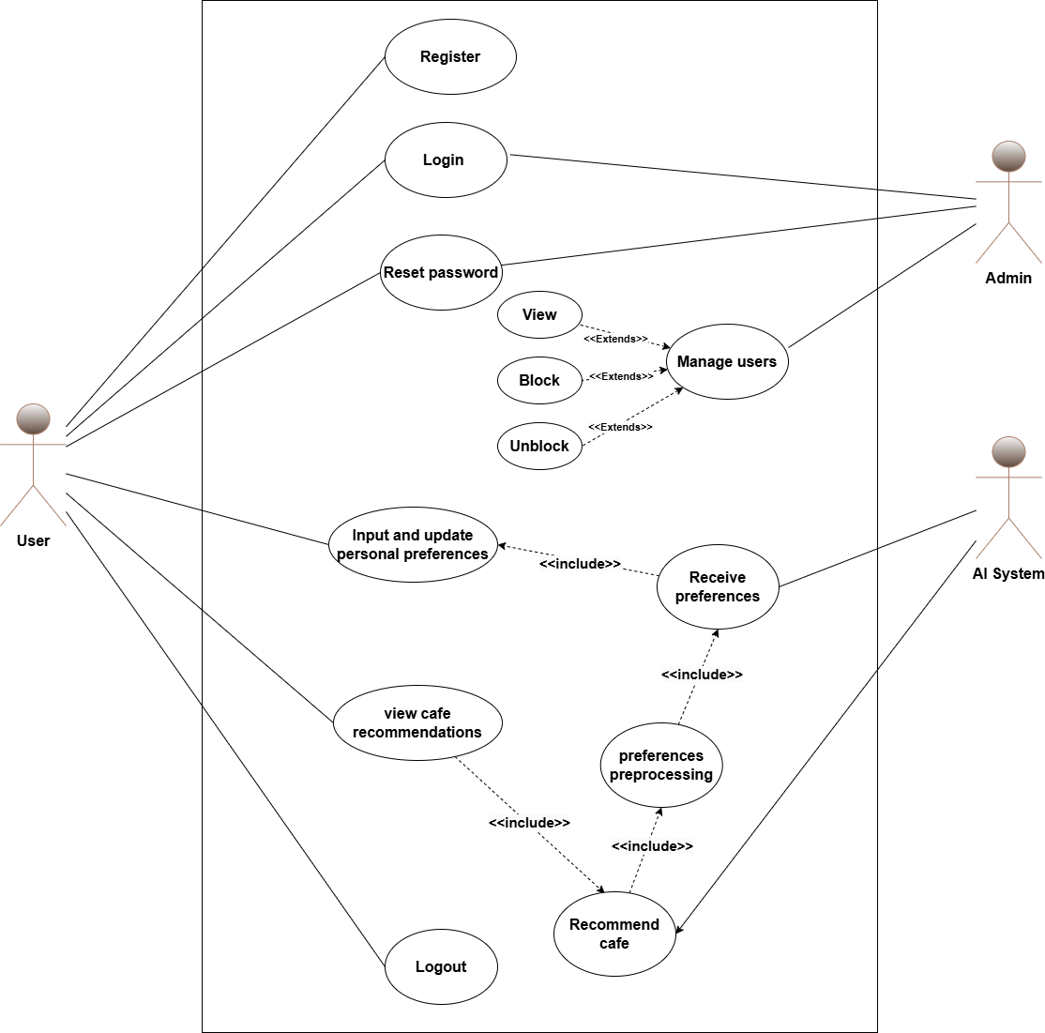
The use case diagram of our system is shown in the figure 4.1.

Figure 4. 1: Use Case Diagram

4.7.2 Sequence Diagram
This diagram shows the external actors, the messages or methods of these actors, the return values, and any loop pointers. The following diagram shows a sequence diagrams of the proposed system.

4.7.2.1 Sequence Diagram for Sign-Up
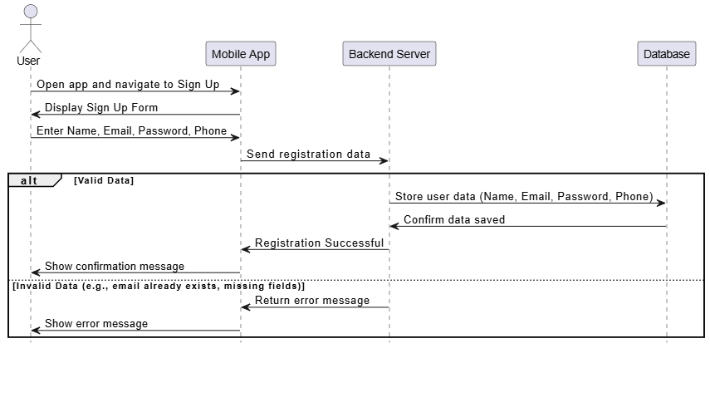
Sequence diagram for sign-up as shown in figure 4.2.

Figure 4. 2: Sequence Diagram for Sign-Up

4.7.2.2 Sequence Diagram for Login
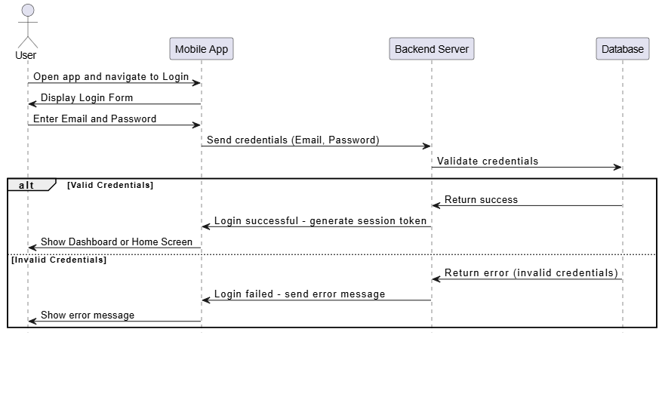
Sequence diagram for login as shown in figure 4.3.

Figure 4. 3: Sequence Diagram for Login

4.7.2.3 Sequence Diagram for Cafes Recommendations
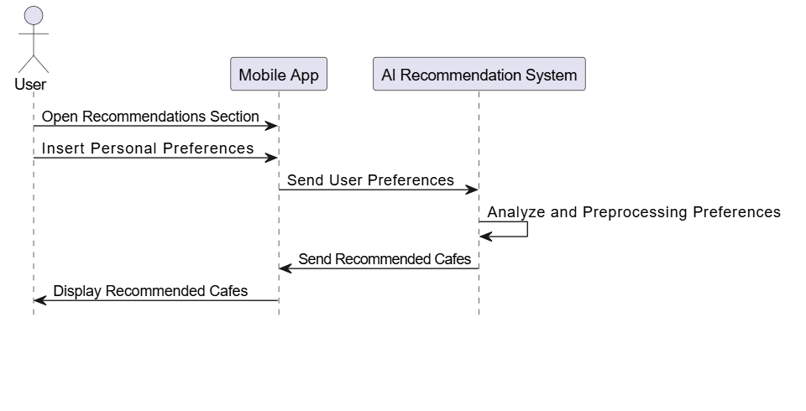
Sequence diagram for Cafe’s recommendations as shown in figure 4.4.
Figure 4. 4: Sequence Diagram for Cafes Recommendations

4.8 Summary
In this chapter, we delved into the critical processes of eliciting requirements, analyzing system requirements, creating and using personas, and developing system models. Each of these components played a pivotal role in the early stages of system development, ensuring that the resulting system aligned with user needs and organizational goals.

Chapter 5: System Design

5.1 Introduction
In this chapter, we will explore the design phase of our project, with a particular focus on the object-oriented development model. By applying object-oriented principles, we leverage a methodology that promotes usability and supports collaborative development. This approach brings numerous benefits, such as improved code reusability, enhanced efficiency, and greater scalability. In the following sections, we will dive into the architectural design, user interface design, and database design, aiming to build a robust and efficient system.

5.2 Mobile Interfaces
Below are sample designs of interfaces for our application.

5.2.1 Splash Interface
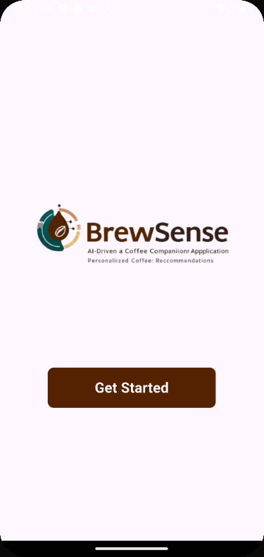
Splash page is shown in Figure 5.1.
Figure 5. 1: Home Interface

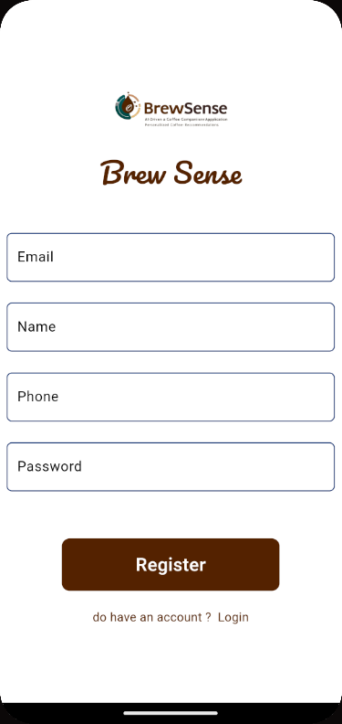
5.2.2 Sign-up Interface
Figure 5. 2: Sign-up Interface
Sign-up page is shown in Figure 5.2.

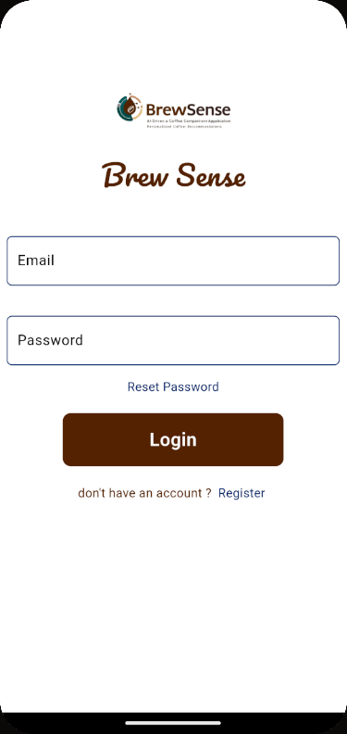
5.2.3 Login Interface
Login page is shown in Figure 5.3.

Figure 5. 3: Login Interface

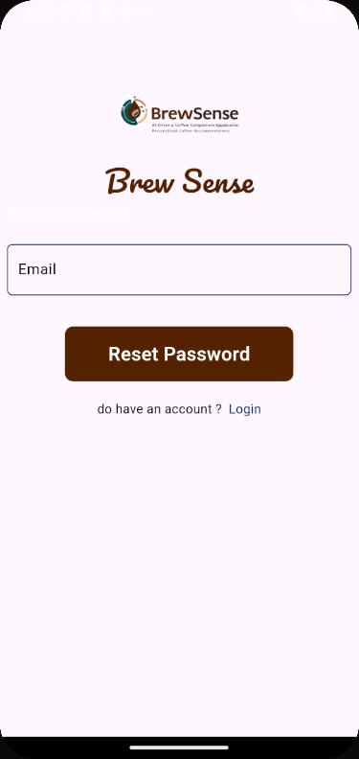
5.2.4 Reset Password Interface
Figure 5. 4: Reset Password Interface
Reset password page is shown in Figure 5.4.


5.2.5 Cafes Recommendation Interface
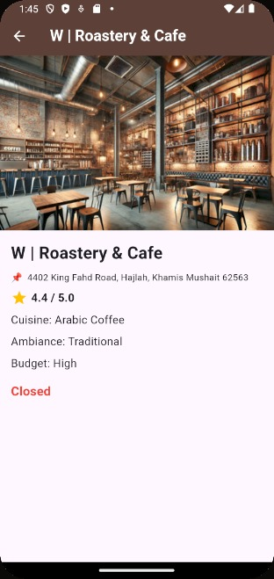
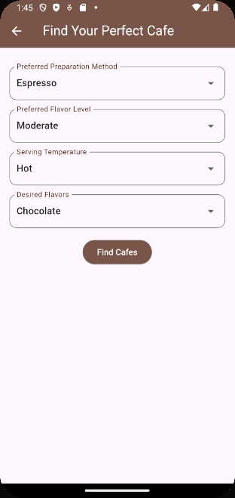
Cafes recommendation page is shown in Figure 5.5.

Figure 5. 5: Cafes Recommendation Interface


5.2.6 Admin Manage Users Interface
Meal recommendation page is shown in Figure 5.6.

Figure 5. 6: Admin Manage Users Interface

5.3 Data Storage
In this section, we will develop Entity-Relationship (ER) diagrams to visually represent the system’s data model and construct a comprehensive data dictionary. The ER diagrams will help illustrate the structure and relationships between various data entities within the system. The data dictionary will serve as detailed documentation, describing each data element along with its attributes, definitions, data types, and any applicable constraints.

5.3.1 Entity-Relationship (ER) Diagrams
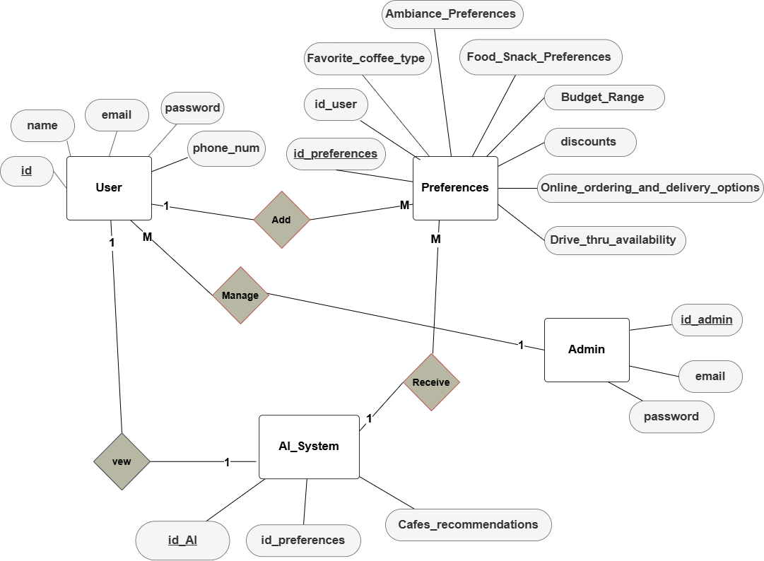
An entity-relationship (ER) diagram, as shown in Figure 5.8, is a visual representation used in database design to illustrate the structure of a database.
Figure 5. 7: Entity-Relationship (ER) Diagrams

5.3.2 Data Dictionary
A data dictionary for mobile application provides a comprehensive description of the data elements used in the system. It defines the data attributes, their properties, and their relationships.
5.3.2.2 User Table
Table 5. 1: Table 1: User
Column Name | Data Type | Constraints | Description
id_user | INT | PRIMARY KEY, AUTO_INCREMENT | Unique identifier for the user
name | VARCHAR(15) | NOT NULL | User's name
email | VARCHAR(32) | NOT NULL | User's email address
password | VARCHAR(15) | NOT NULL | User's password

5.3.2.2 Preferences Table
Table 5. 2: Preferences Table
Column Name | Data Type | Constraints | Description
id_preferences | INT | PRIMARY KEY, AUTO_INCREMENT | Unique identifier for the preferences
id_user | INT | FOREIGN KEY REFERENCES User(id) | User ID associated with the preferences
Favorite_coffee_type | VARCHAR(255) | NOT NULL | User's favorite coffee type
Food_Snack_Preferences | TEXT | NOT NULL | User's food and snack preferences
Budget_Range | VARCHAR(255) | NOT NULL | User's budget range
discounts | BOOLEAN | NOT NULL | Indicates if the user wants to receive discounts
Online_ordering_and_delivery_options | BOOLEAN | NOT NULL | Indicates if the user prefers online ordering and delivery
Drive_thru_availability | BOOLEAN | NOT NULL | Indicates if the user prefers drive-thru availability
Ambiance_Preferences | TEXT | NOT NULL | User's ambiance preferences

5.3.2.3 AI Model Table
Table 5. 3: AI Model Table
Column Name | Data Type | Constraints | Description
id_AI | INT | PRIMARY KEY, AUTO_INCREMENT | Unique identifier for the AI model
id_preferences | INT | FOREIGN KEY REFERENCES Preferences(id_preferences) | Preferences ID associated with the AI system
Cafes_recommendations | TEXT | NOT NULL | Recommendations of cafes based on user preferences

5.3.2.4 The Admin Table
Table 5. 4: The Admin Table
Column Name | Data Type | Constraints | Description
id_admin | INT | PRIMARY KEY, AUTO_INCREMENT | Unique identifier for the admin
email | VARCHAR(32) | NOT NULL | Admin's email address
password | VARCHAR(10) | NOT NULL | Admin's password

5.4 High-Level Design
In this section, we will explore the creation of class diagrams and delve into discussions of system architecture. Class diagrams provide a visual representation of the system structure, illustrating classes, their attributes, methods, and relationships, we will discuss system architecture, which includes the high-level design of the system, including its components, interactions, and deployment strategies.

5.4.1 Class Diagram
A class diagram is a type of UML diagram that illustrates the static structure of a system by depicting its classes, along with their attributes, methods, and the relationships among them. It serves as a key tool for visualizing and designing the architecture of an object-oriented system. Figure 5.8 below presents the class diagram of the proposed system.
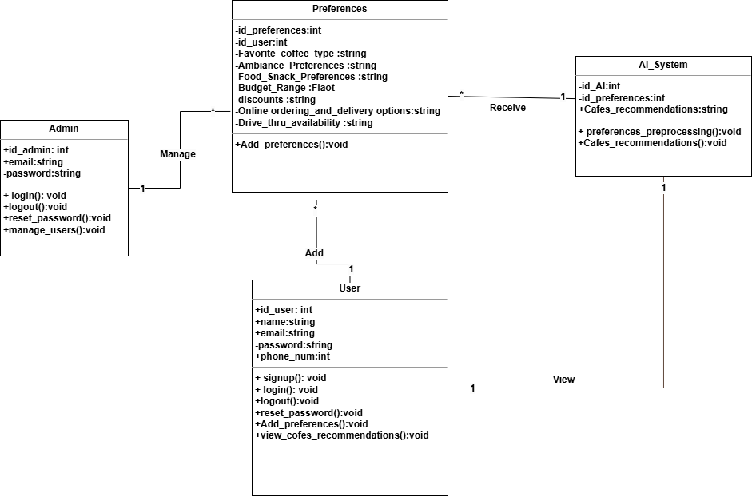

Figure 5. 8: Class Diagram

5.4.2 System Architecture
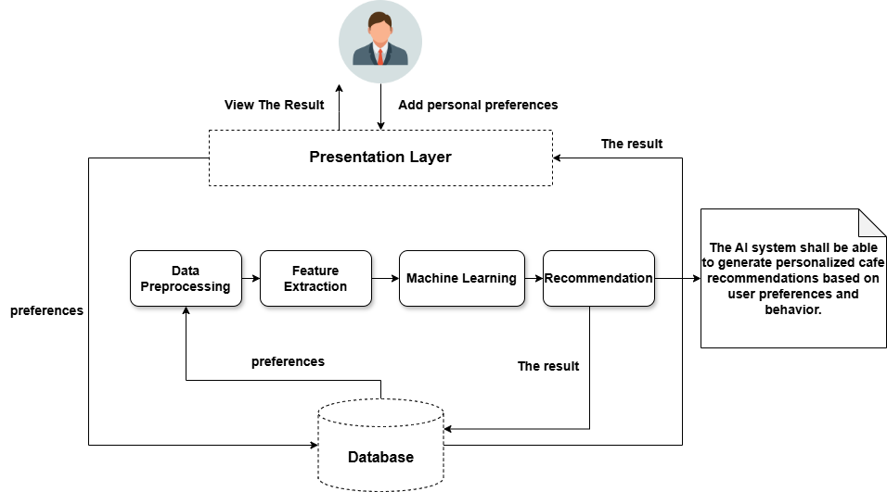
A Collaboration Diagram, also referred to as a Communication Diagram, visually represents the interactions between various components or objects within a system. It focuses on the structure of the relationships and how objects collaborate, rather than the specific sequence of messages exchanged. Figure 5.9 below illustrates the collaboration diagram for the proposed system.
Figure 5. 9: System Architecture

5.5 Summary
In this chapter, we explored the design phase of our project, emphasizing the object-oriented development model. By applying object-oriented principles, we adopted an approach that improved usability and supported collaborative development. This methodology provided several key benefits, including code reusability, increased efficiency, and enhanced scalability. Additionally, we examined the architectural design, user interface design, and database design in detail, aiming to build a well-structured and efficient system.

Chapter 6: Conclusion and Future Work

6.1 Future Work
The AI model will analyze user preferences and recommend cafés accordingly.
1. AI Model
1.1 Data Collection & Preprocessing
- Gather café datasets containing attributes like location, cuisine, ambiance, budget, ratings, and user reviews.
- Collect user preference data from app interactions, search history, and ratings.
- Clean and preprocess data using Pandas & NumPy (Python).
1.2 Model Development
- Use Collaborative Filtering (Matrix Factorization) for personalized recommendations.
2. Mobile Application (Flutter & Dart Implementation)
2.1 Project Setup
- Install Flutter & Dart SDK.
- Set up a Firebase backend for authentication and real-time database.
2.2 User Authentication & Profile Management
- Firebase Authentication for user login, registration, and password reset.
2.3 AI Integration with Flutter
- Make HTTP requests from Flutter to fetch AI-generated recommendations using or HTTP package.
- Display recommended cafés dynamically.
2.4 Admin Panel Implementation
- Develop an admin dashboard in Flutter to manage user accounts (view, block, unblock).
- Implement Firestore-based user role management.
3. Testing & Deployment
3.1 Testing the AI Model
- Evaluate model accuracy using Precision, Recall, and RMSE (Root Mean Square Error).
3.2 Mobile App Testing
- Perform Widget Testing using flutter test package.
- Conduct integration testing to validate Firebase authentication and AI API responses.

6.2 Summary
The AI-powered café recommendation app for Abha provides a seamless and personalized experience for users looking to discover cafés that match their preferences. By leveraging artificial intelligence, the application efficiently analyzes user preferences, such as ambiance, budget, and cuisine choices, to offer tailored recommendations. The integration of a user-friendly interface ensures accessibility for different user demographics, including students, professionals, and coffee enthusiasts. Additionally, the admin panel allows for effective user account management, ensuring smooth operations.
With this app, users no longer need to rely on time-consuming searches or generic recommendations. Instead, they receive curated suggestions that enhance their café experiences. This smart solution significantly improves user satisfaction while promoting local businesses by increasing their visibility.

REFERENCES

- Fakhri, A. A., Baizal, Z. K. A., & Setiawan, E. B. (2019). Restaurant Recommender System using User-Based Collaborative Filtering Approach: A case study at Bandung Raya region. Journal of Physics Conference Series, 1192, 012023. https://doi.org/10.1088/1742-6596/1192/1/012023
- Balabanović, M., & Shoham, Y. (1997). Fab. Communications of the ACM, 40(3), 66–72. https://doi.org/10.1145/245108.245124
- Jain, A., Nagar, S., Singh, P. K., & Dhar, J. (2020). EMUCF: Enhanced multistage user-based collaborative filtering through non-linear similarity for recommendation systems. Expert Systems with Applications, 161, 113724.
- Siagian, Christian Andreas, Eunike Endariahna Surbakti, and Yaman Khaeruzzaman. "Recommendation System Coffee Shop using AHP and TOPSIS Methods." Ultimatics: Jurnal Teknik Informatika 16.1 (2024): 46-53.‏
- Kesorn, K., Juraphanthong, W., & Salaiwarakul, A. (2017). Personalized attraction recommendation system for tourists through check-in data. IEEE access, 5, 26703-26721.‏
- Lin, F. C., Yu, H. W., Hsu, C. H., & Weng, T. C. (2011). Recommendation system for localized products in vending machines. Expert systems with applications, 38(8), 9129-9138.
- Hao, F., & Blair, R. H. (2016). A comparative study: classification vs. user-based collaborative filtering for clinical prediction. BMC medical research methodology, 16, 1-14.
- Chen, J., Wang, X., Zhao, S., Qian, F., & Zhang, Y. (2020). Deep attention user-based collaborative filtering for recommendation. Neurocomputing, 383, 57-68.
- Chen, Z., Wang, Y., Zhang, S., Zhong, H., & Chen, L. (2021). Differentially private user-based collaborative filtering recommendation based on k-means clustering. Expert Systems with applications, 168, 114366.‏
- Chen, Z., Wang, Y., Zhang, S., Zhong, H., & Chen, L. (2021). Differentially private user-based collaborative filtering recommendation based on k-means clustering. Expert Systems with applications, 168, 114366.‏‏‏‏
- Download the BeanHunter iPhone and Android mobile app. (n.d.). https://www.beanhunter.com/mobile#app-downloads
- European Coffee Trip - apps on Google Play. (n.d.-b). https://play.google.com/store/apps/details?id=cz.europeancoffeetrip.android
- CoffeeStep Coffee Subscription - apps on Google Play. (n.d.). https://play.google.com/store/apps/details?id=com.coffeestep.app
- Coffee Guru. (2019, May 21). Home | Coffee.guru. Coffee.guru. https://coffee.guru/
- “Introducing Types of UML Diagrams | Lucidchart Blog.” Accessed: Nov. 05, 2023. [Online]. Available: https://www.lucidchart.com/blog/types-of-UMLdiagram

